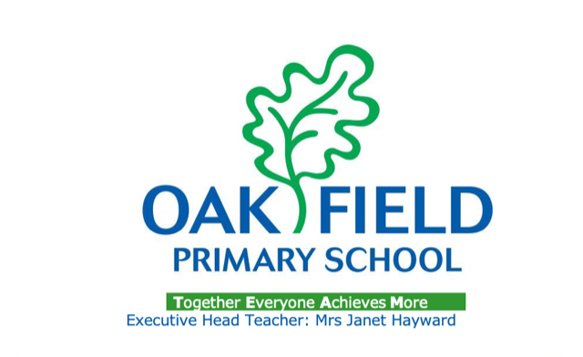
Oak Field Primary School
Charging Policy

Purpose of Policy
The purpose of this policy is to set out what charges can and cannot be made for activities at Oak Field Primary School. The policy has been drawn up in accordance with Sections 449-462 of The Education Act 1996 which sets out the law regarding what charges can and cannot be made for activities in schools maintained by local authorities.

Circumstances where no charge is made
No charge will be made for:
* Education in School
* Education provided wholly or mainly during school hours.
* Admission to school for children of compulsory school age.
* Activities which are part of the National Curriculum, or are part of a prescribed examination syllabus, or part of Religious Education.
* The supply of any materials, books and instruments or other equipment.
* Transporting registered pupils to or from the school premises, where the local authority has a statutory obligation to provide transport.
* Transporting registered pupils to other premises where the governing body or local authority has arranged for pupils to be educated.
* Transport provided in connection with an educational visit which is part of the Curriculum.

Circumstances where the school may charge Parents “Optional Extras”
Charges may be made for other activities known as ‘optional extras’. Where an optional extra is being provided, a charge may be made for providing materials, books, instruments, or equipment as follows:

Education
* Activities which take place mainly or wholly out of school time if they are not part of the National Curriculum, not part of a syllabus for a prescribed public examination that the pupils being prepared for at the school and not part of religious education.
* Materials used in practical subjects and project assignments provided parents have agreed in advance that they or the pupil wish to keep the finished product e.g. ingredients or materials.

Music tuition
* Musical instrument tuition provided to individual pupils or to a group of not more than four pupils if the teaching of music tuition is not part of the National Curriculum or a public examination syllabus being followed by the pupil.

Transport
* Transport that is not required to take the pupil to school or to other premises where the governing body have arranged for the pupil to be provided with education.

Board and Lodgings
* The cost of board and lodging for residential trips, even when taking place largely during school time.

Voluntary Contributions

Although schools cannot charge for school time activities, voluntary contributions may be sought from parents for activities which supplement the normal school curriculum.

Requests to parents for voluntary contributions:
* it is a voluntary contribution;
* pupils of parents who cannot contribute will not be treated any differently, however
* where there are not enough voluntary contributions to make the activity possible and there is no way to make up the shortfall, the activity will be cancelled.
Requests made for voluntary contributions made in respect of individual pupils must not include any element of subsidy for any other pupils wishing to participate in the activity whose parents are unwilling or unable to pay the full charge. The governing body may wish to remit in full or in part, the cost of other activities for parents in certain circumstances.
Breakages and Damage
Where a pupil’s behavior results in damage to school property or equipment, parents may be asked to pay for the necessary repair or replacement. Each incident should be dealt with on its own merit and at the schools discretion.
Equalities
We are fully committed to equality of opportunities for all associated with our school. Pupils will not be excluded from activities through parents’ inability or unwillingness to pay. We ensure that there is no discrimination at Oak Field Primary School on grounds of:
* Disability
* Gender reassignment
* Marriage and civil partnership
* Pregnancy and maternity
* Race
* Religion or belief
* Sex (gender)
* Sexual orientation
* The Welsh language in Wales
* Age (applicable to all except pupils)

